**How to test if the transducers are working:**

1. On the meter, set pipe diameter to 25mm (or 1 inch).
2. The mount method does not matter for testing.
3. Assemble transducers so they are opposing each other, (see picture below) make sure you use couplant between the 2 transducers.
4. The RH20 meter under menu 90 should display 78- 80 % S=856, 858
5. Remove the up cable and you should see S=000, XXX slowly goes to 000
6. Plug up cable back in, remove down cable and you should see S=570, 000 Sometimes both go to 000, but down will go faster to 000
7. If you see the above then both cables are working, when either one is removed that side will go to 000.
8. If none of this is happening then your meter will have to be returned for repair. It could be transducer or wiring to the meter, or the meter itself.

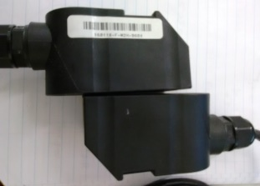

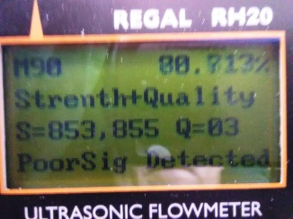 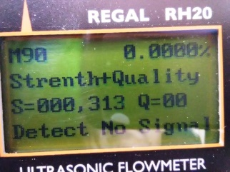 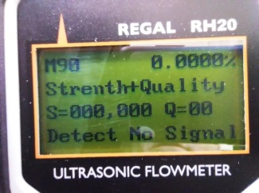

With transducers opposing each other Up transducer removed Down transducer removed, down drops fastest.